19 august, 2026
Today’s topic-
Lighting mode:
- How to create app, object, field
- Validation rule
- Page layout
- Tabs
- Themes and branding
Data migration tools-
- Data import wizard
- Data export wizard
- Data louder
- Workbench
1)How to create app?
Step 1: switching to lighting mode.
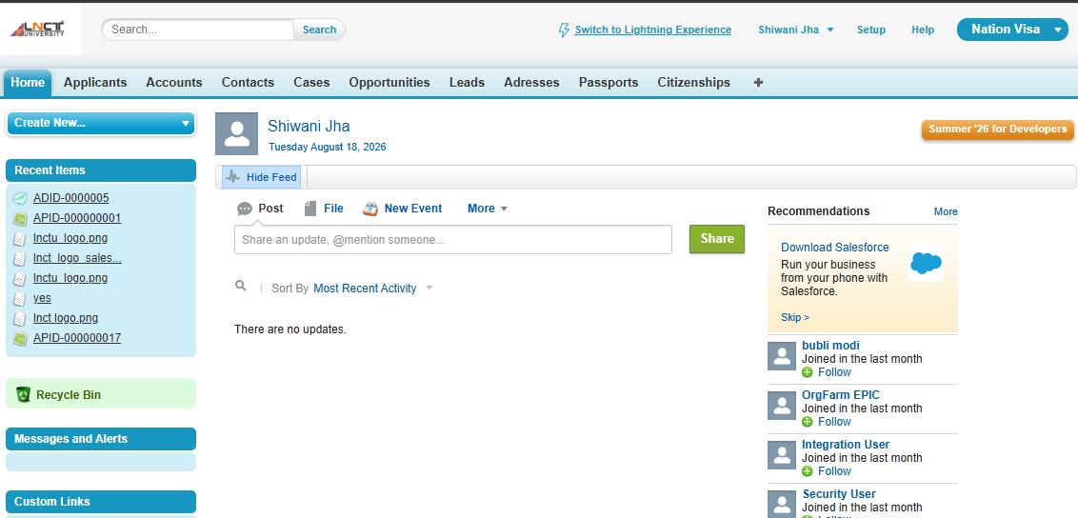
Step 2
Click on this-

Step 3
App launcher
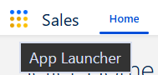
Step 4
Setup- Go to Setup.
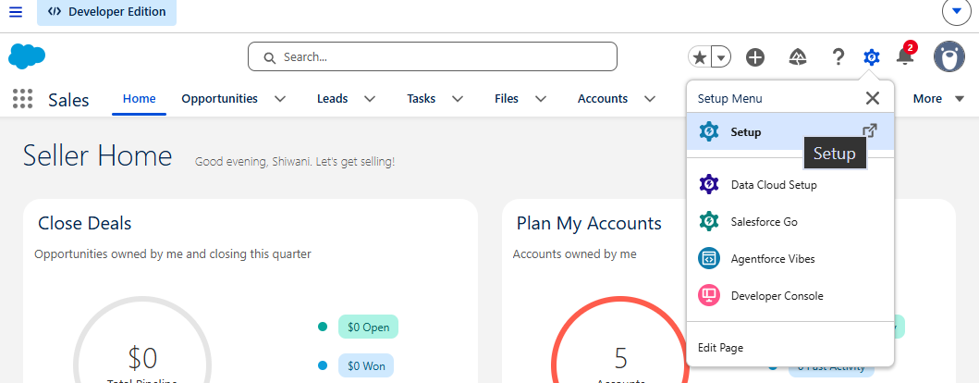
Step 5: In Quick Find, search App Manager.
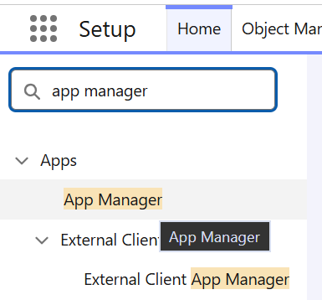

Step 6: Click New Lightning App.
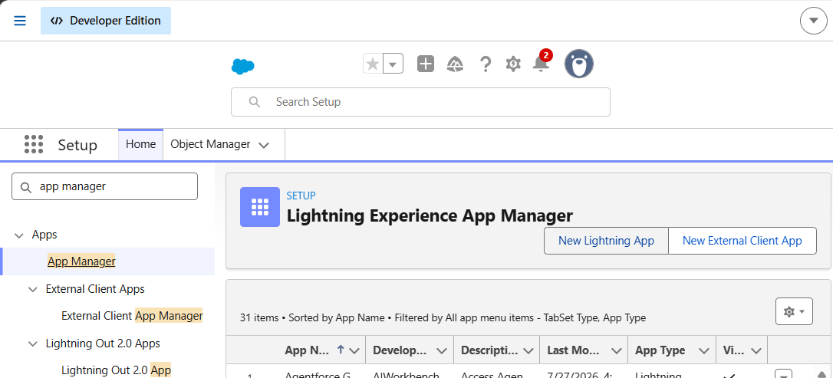
Step 7: Enter the App Name.

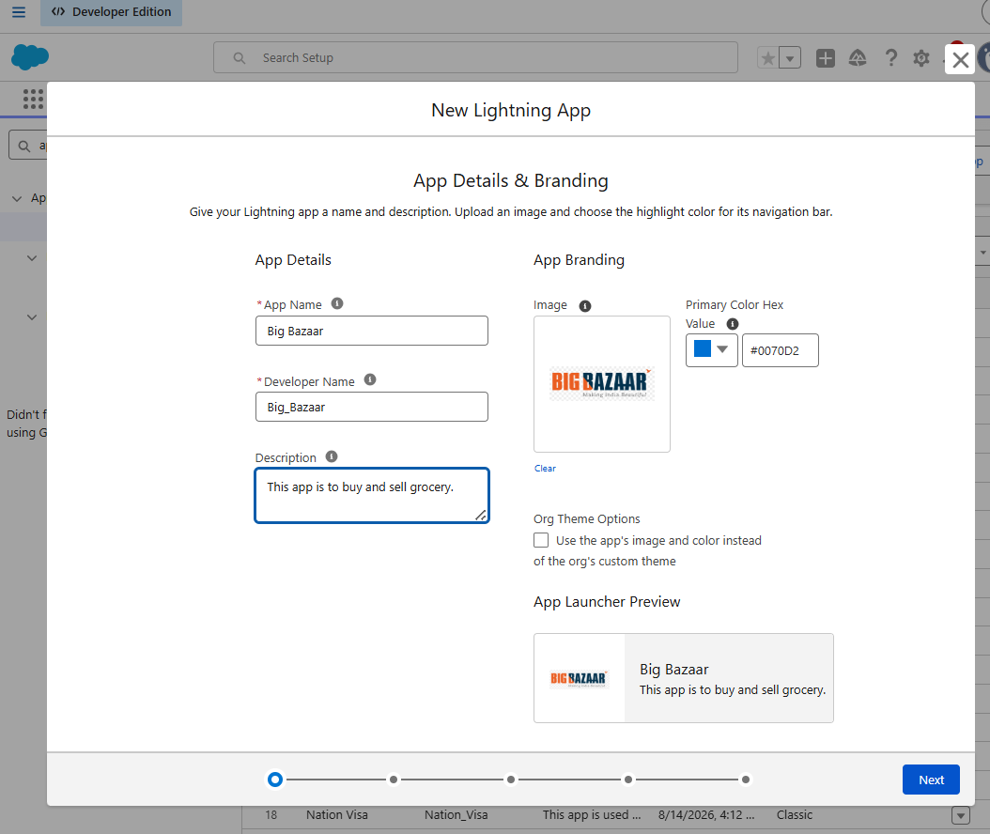
Step 8: Add the required app details and branding.

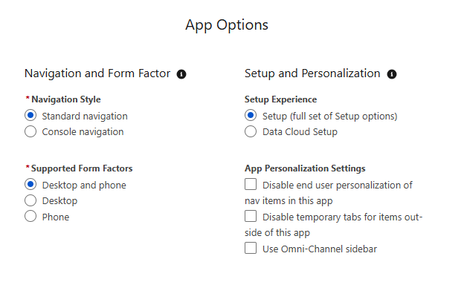

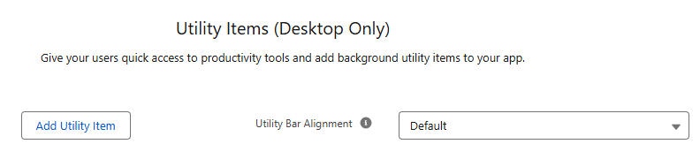
- Select the navigation items/tabs that you want in the app.
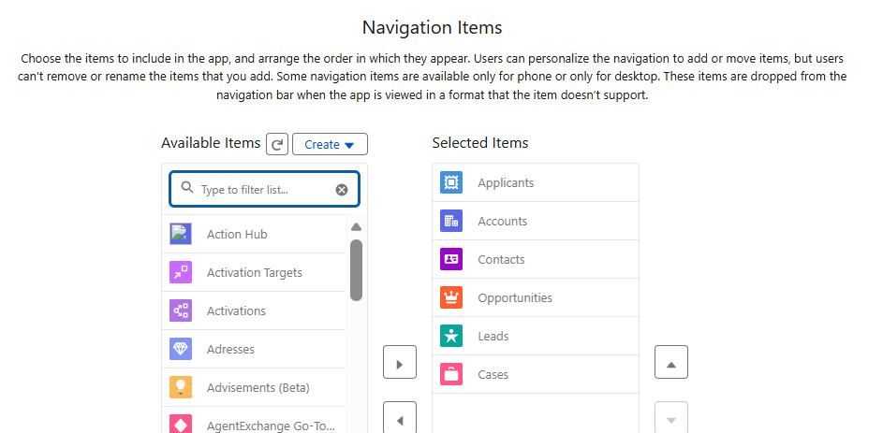
- Assign the app to the required profiles.
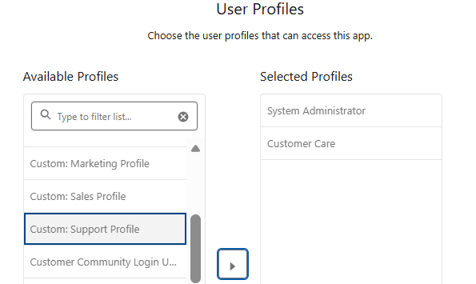
- Click Save & Finish.
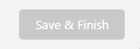

Result- The new Lightning App will appear in the App Launcher.
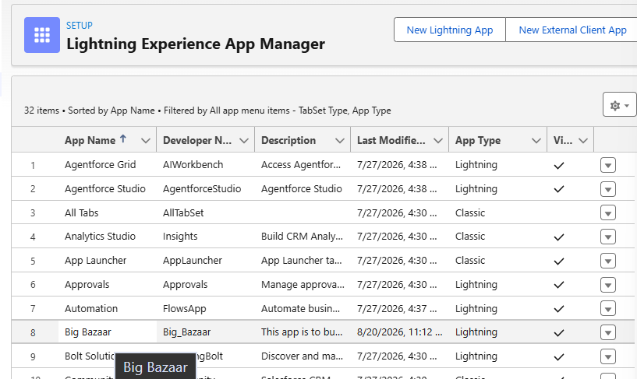
Search in app launcher-
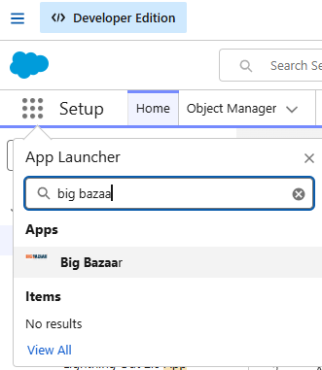
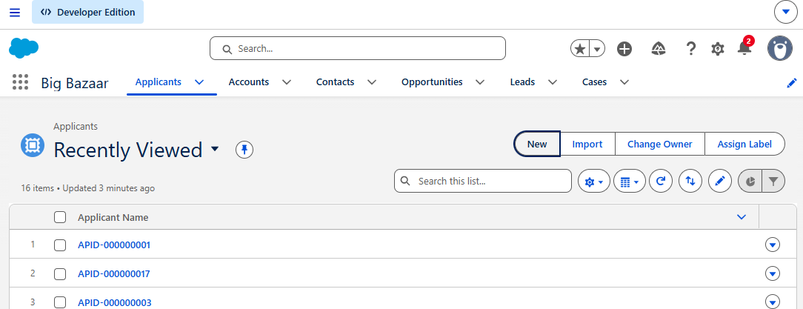

1)How to create object and field?
Steps
Step 1: Go to Setup → Object Manager.
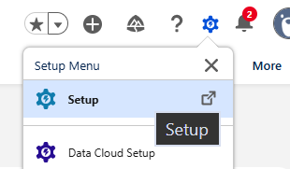

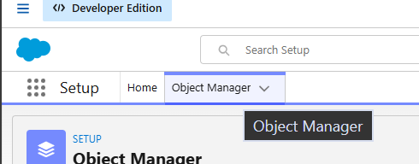
Step 2: Click Create → Custom Object.
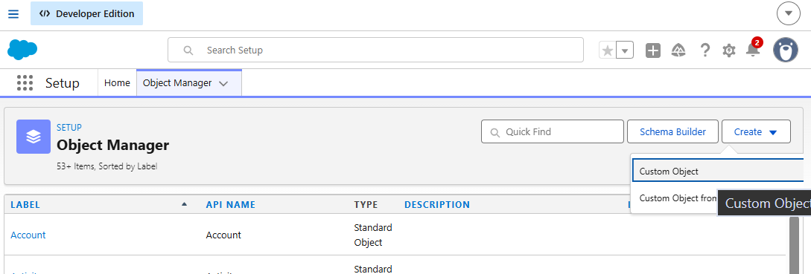
Step 3: Same interface of classical will be there so just follow the previous steps.
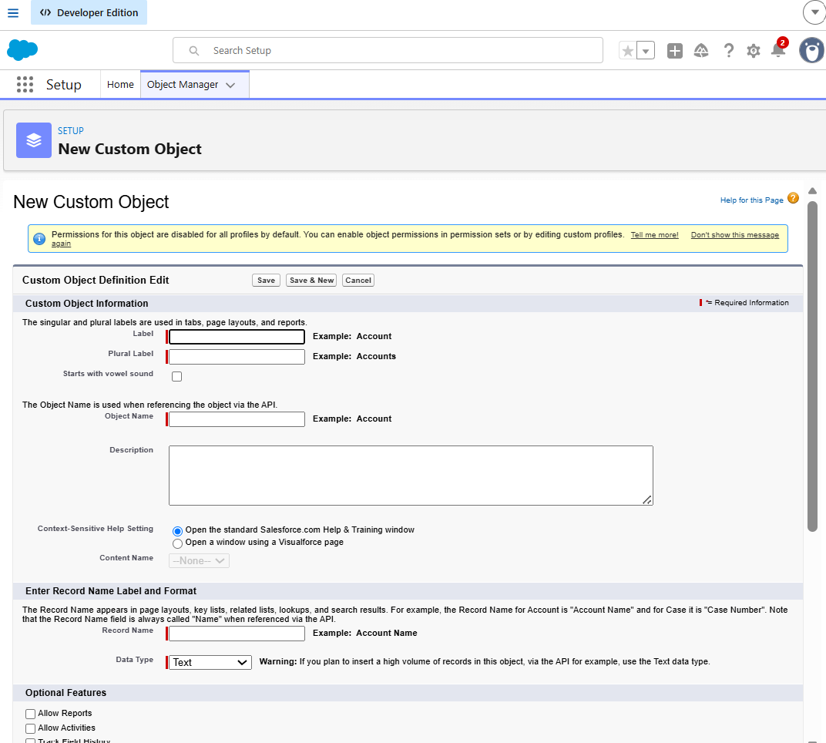
Step 4: Select the required Record Name type.
For example: Text & Auto Number
Step 5: Select the required object options.
Step 6: Click Save.
Result: The custom object is created and appears in Object Manager.

Create a Field
Steps
Step 1: Go to Setup → Object Manager.
Step 2: Select your object.
Example:
Applicant
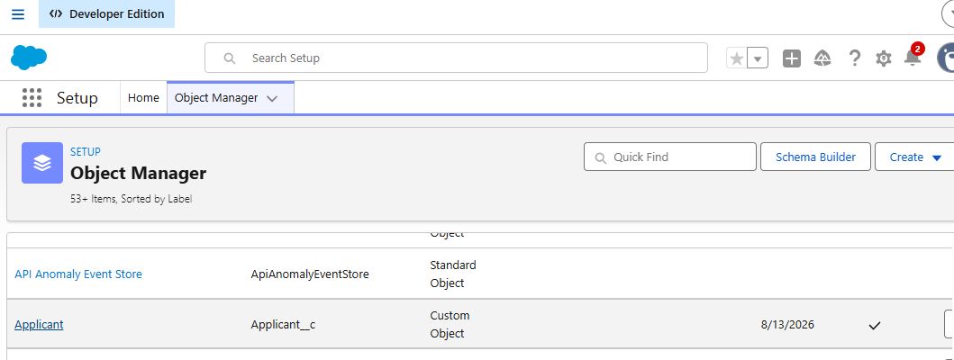
Step 3: Open Fields & Relationships.
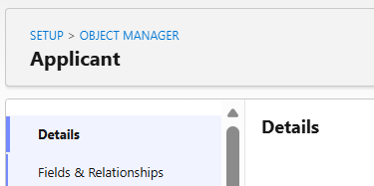
Step 4: Click New.
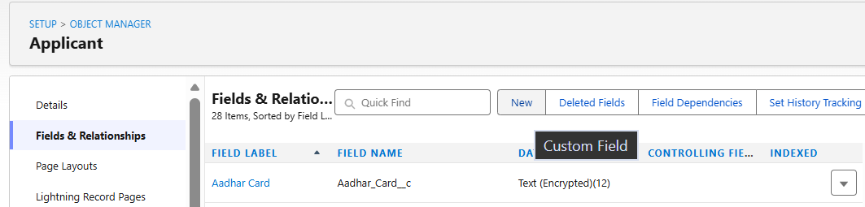
Step 5: Select the required Data Type.
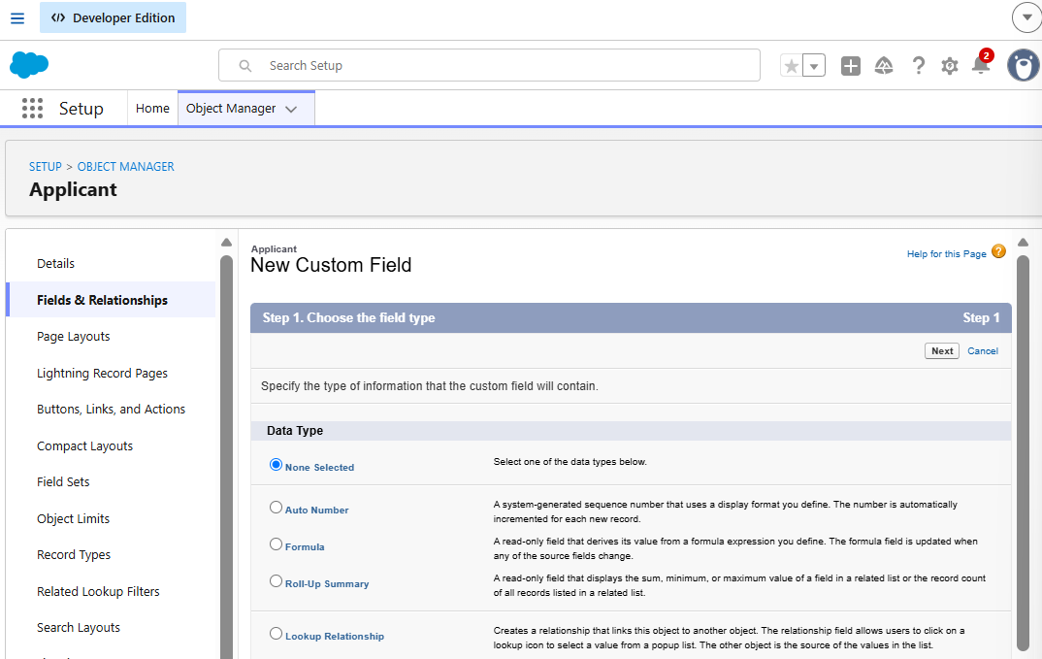
Step 6: Click Next.
Step 7: Enter the Field Label and other required details.
Step 8: Set field-level security if required.
Step 9: Add the field to the required page layouts.
Step 10: Click Save.

2)Validation Rule
A Validation Rule is used to prevent users from saving a record when specific conditions are not satisfied.
Steps
Step 1: Go to Setup → Object Manager.
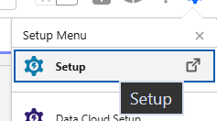
Step 2: Select the required object.
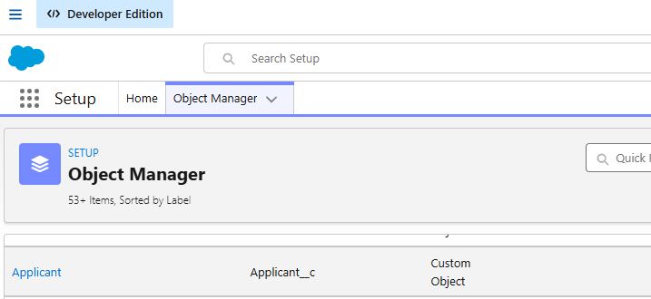
Step 3: Open Validation Rules.
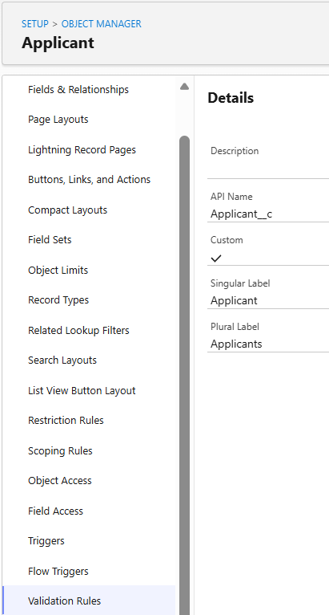
Step 4: Click New.
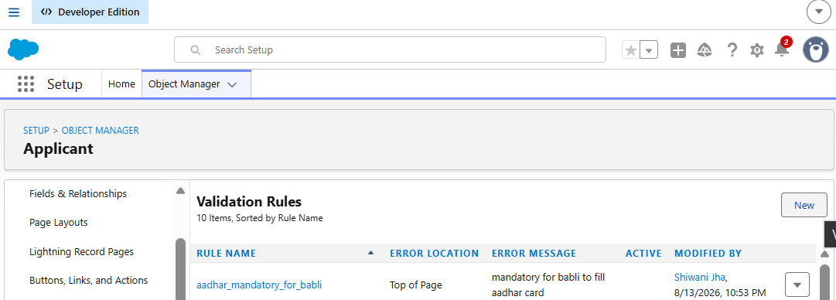
Step 5: Enter the Rule Name.
Step 6: Enter the validation formula.
Step 7: Enter the Error Message.
Step 8: Select where the error should be displayed.
It has the same interface like before, so follow same process.
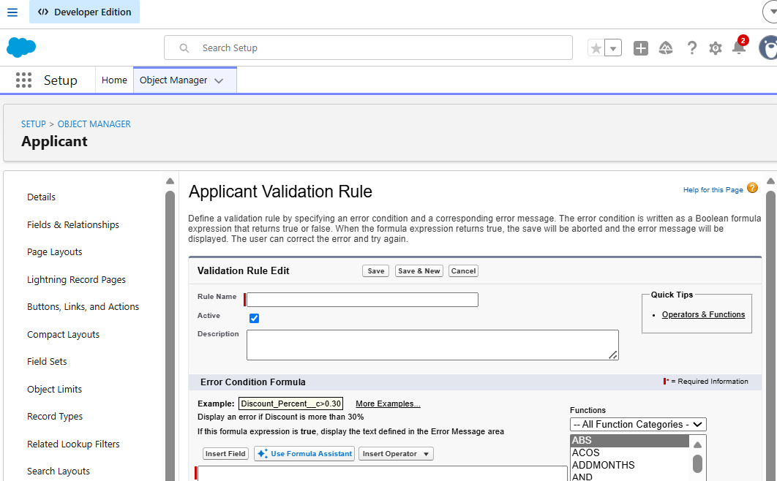
Step 9: Click Save.
Result
When the validation condition is true, Salesforce prevents the record from being saved and displays the error message.

3)Page Layout
A Page Layout controls which fields, buttons, related lists, and other sections are displayed on a record page.
Steps
Step 1: Go to Setup → Object Manager.
Step 2: Select the required object.
Step 3: Click Page Layouts.
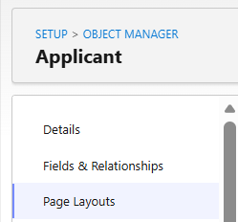
Step 4: Click Edit on the required layout.
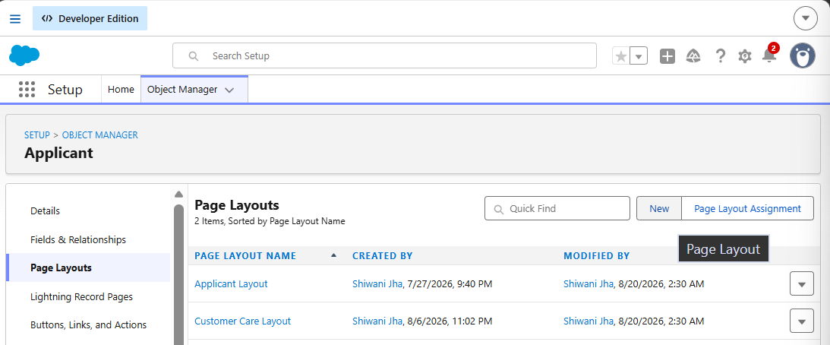
Step 5: Add or remove fields, buttons, sections, and related lists.
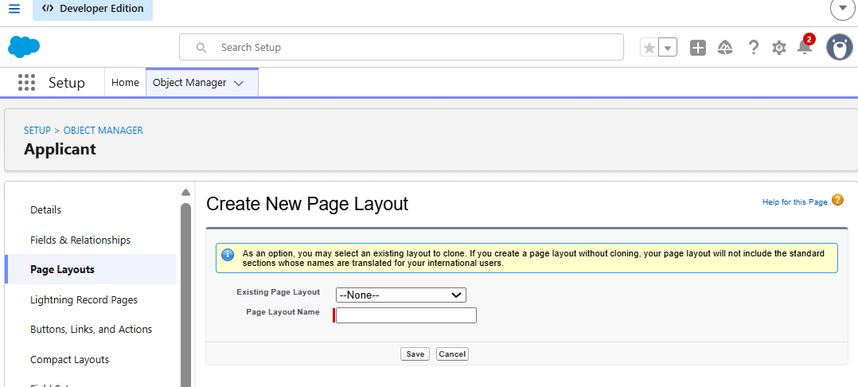
Step 6: Arrange them using drag and drop.
Step 7: Click Save.
Same interface so follow previous steps.

4)Tabs
Tabs are used to provide users with access to objects from the Salesforce navigation bar.
Create a Custom Object Tab
Step 1: Go to Setup.
Step 2: In Quick Find, search Tabs.
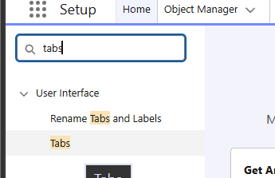
Step 3: Open Tabs.
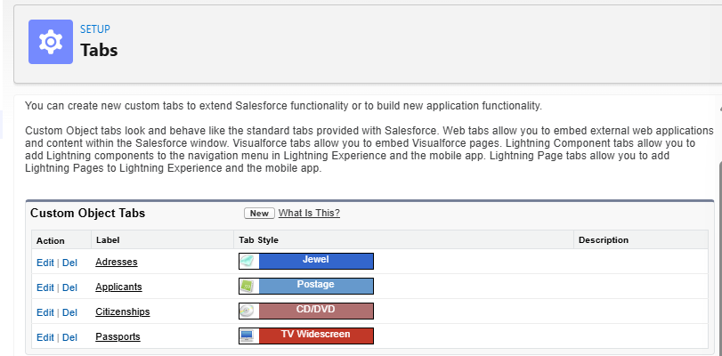
Step 4: Under Custom Object Tabs, click New.
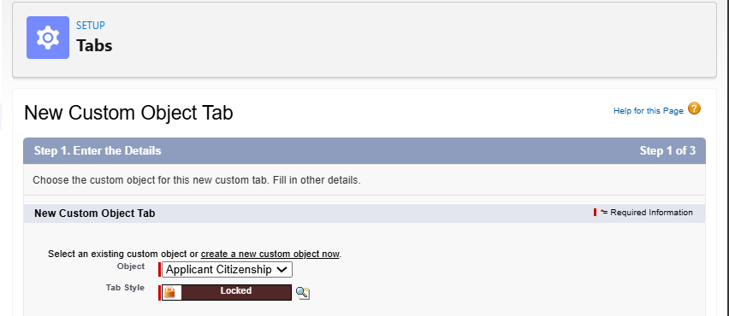
Step 5: Click Next → Save.

Add the Tab to a Lightning App
Step 1: Go to Setup → App Manager.
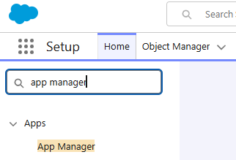
Step 2: Find your Lightning App.
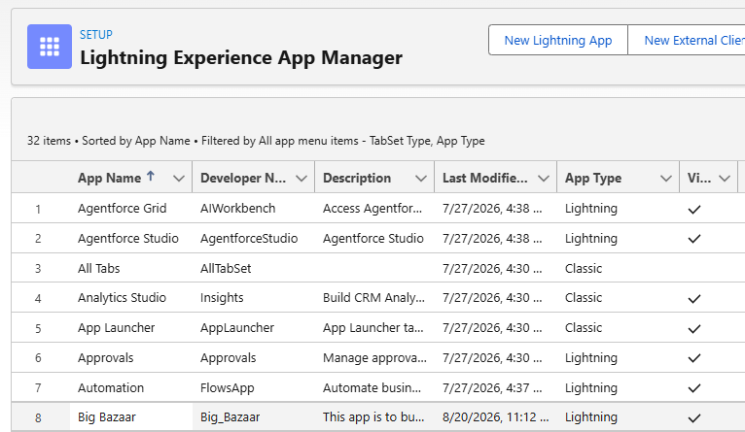
Step 3: Click the dropdown next to it → Edit.
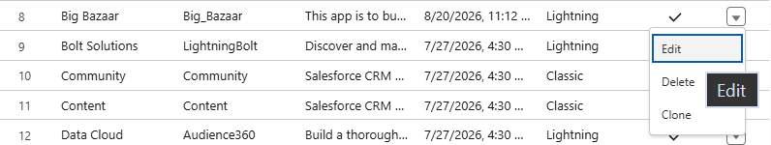
Step 4: Open Navigation Items.
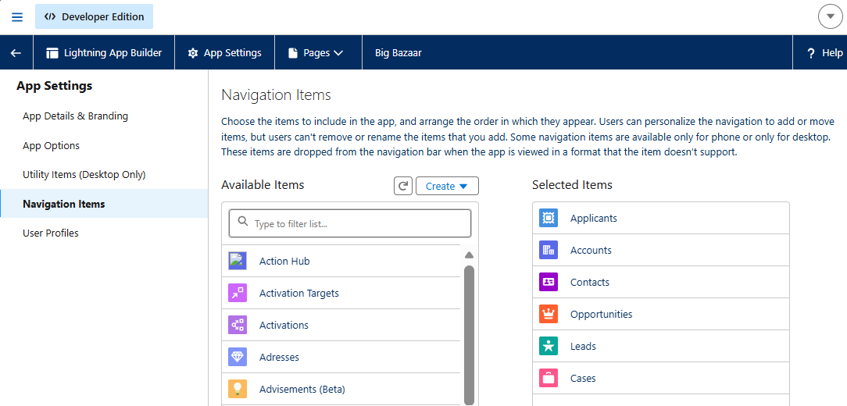
Step 5: Add your object/tab.
Step 6: Click Save.

5)Themes and Branding
Themes and Branding are used to customize the appearance of a Lightning App, such as its logo, colors, and branding.
Steps
Step 1: Go to Setup → App Manager.
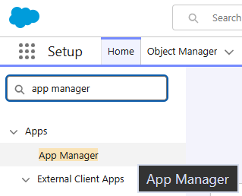
Step 2: Find your Lightning App.
Step 3: Click the dropdown → Edit.
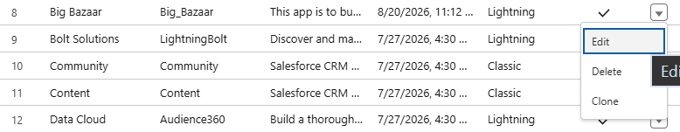
Step 4: Go to App Options / Branding.
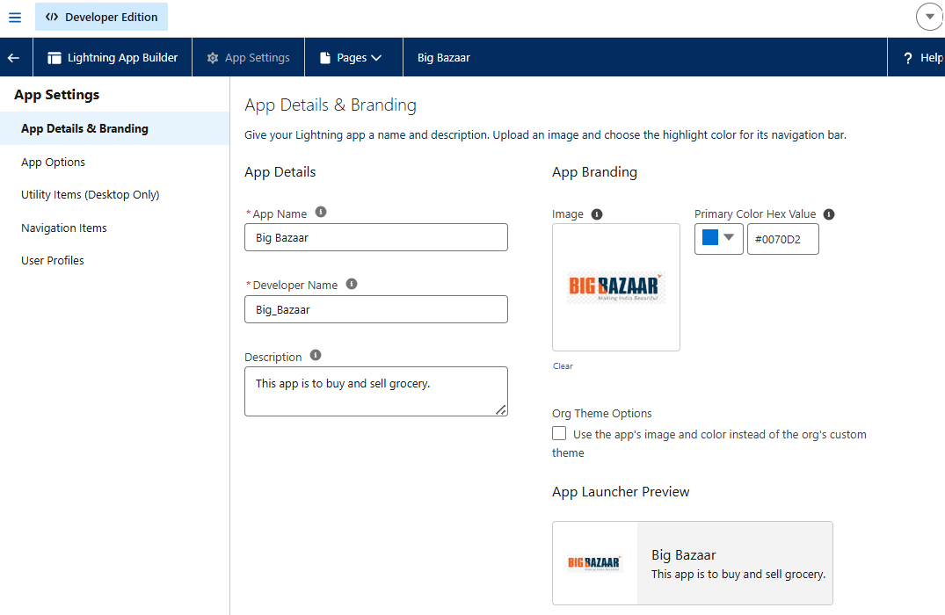
Step 5: Set the required and Save the changes.
Result
The Lightning App will display the selected branding and logo.

Data Migration Tools
1. Data Import Wizard
Data Import Wizard is used to bring data into Salesforce. We can use it when data is required in the Salesforce org for data analysis, reports, and other purposes.
Limitations-
- Maximum: 50,000 records
- Can be used with these 4 standard objects: Account, Contact, Leads & Solution
- Operations mentioned in class: Create, Insert, Update & Upsert
External Data / CSV -> Data Import Wizard -> Salesforce Org
Step 1
Go to Setup.
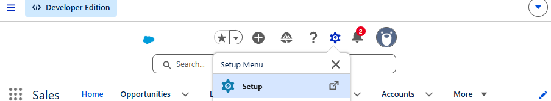
Step 2
In Quick Find, search for:
Data Import Wizard
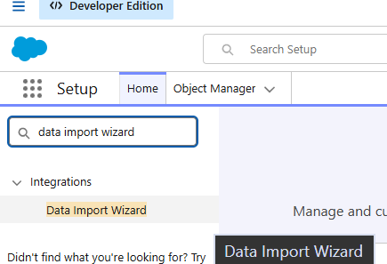
Step 3
Open Data Import Wizard.
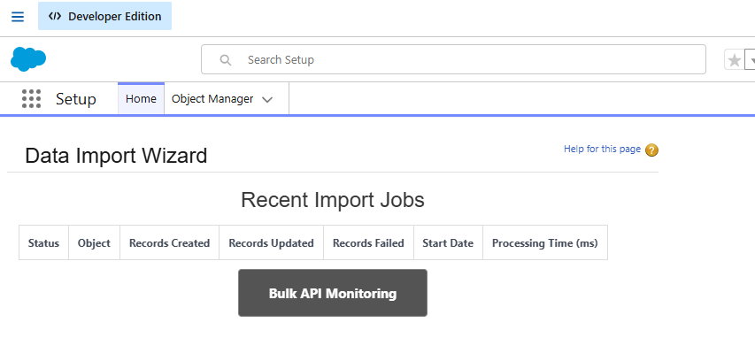
Step 4
Click Launch Wizard.
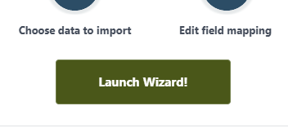
Step 5
Select the object for which you want to import data.
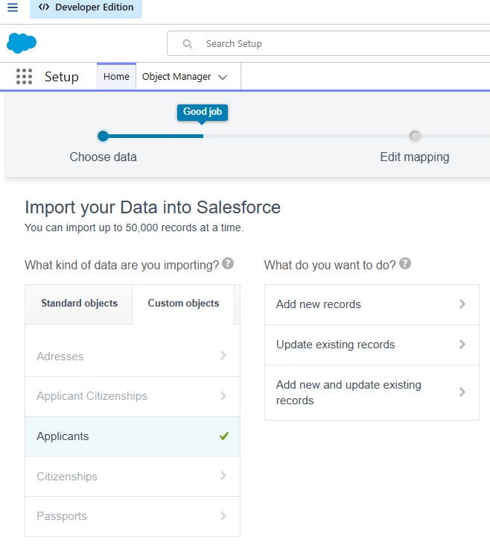
Step 6
Select the operation you want to perform:
- Add New Records
- Update Existing Records
- Add New and Update Existing Records

Step 7
Upload your CSV file.
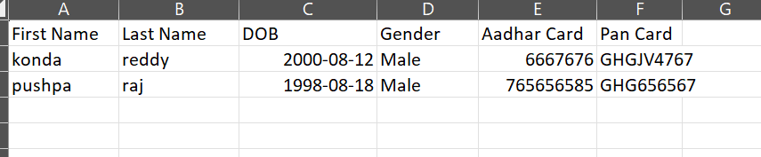

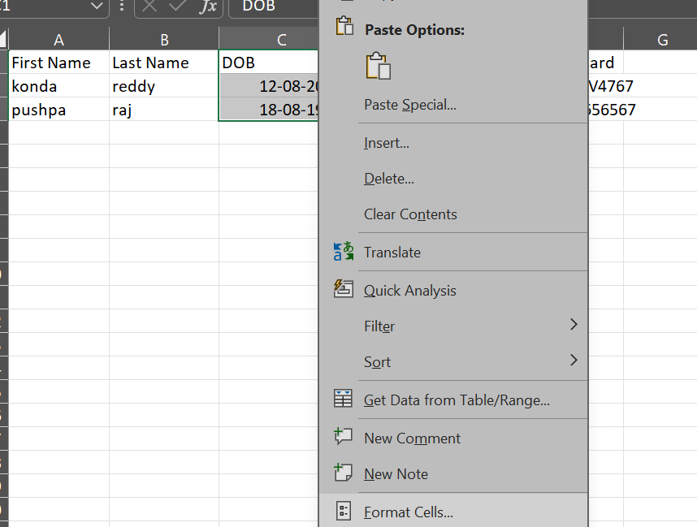
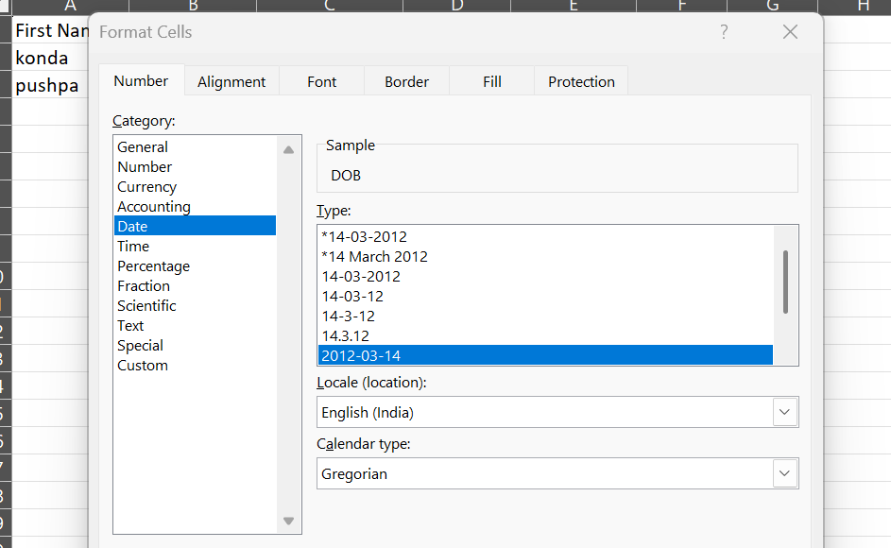
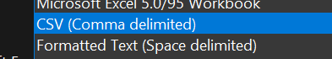
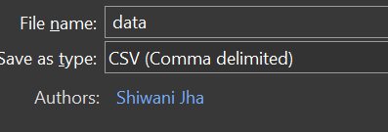
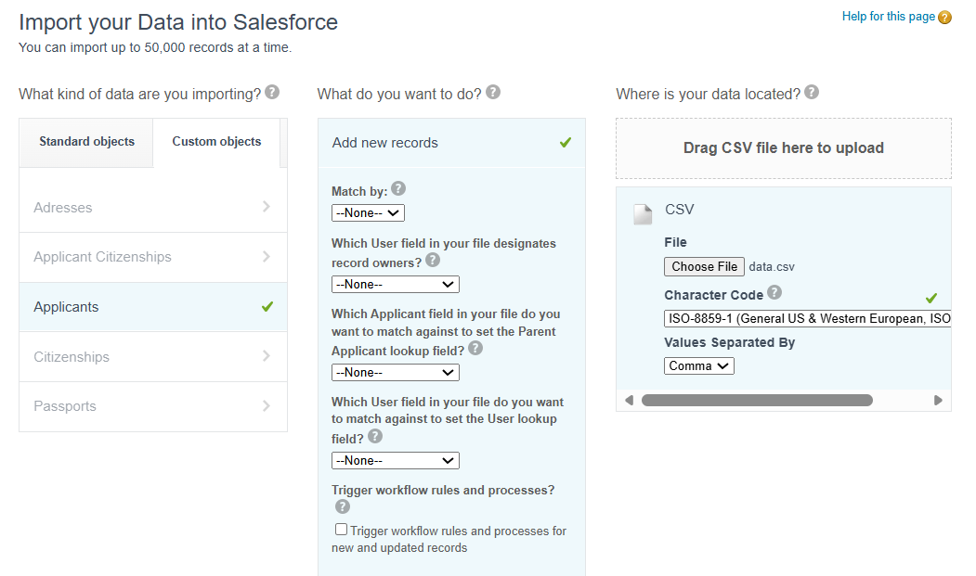

Step 8
Map the CSV fields with the corresponding Salesforce fields.
Step 9
Review the field mapping.
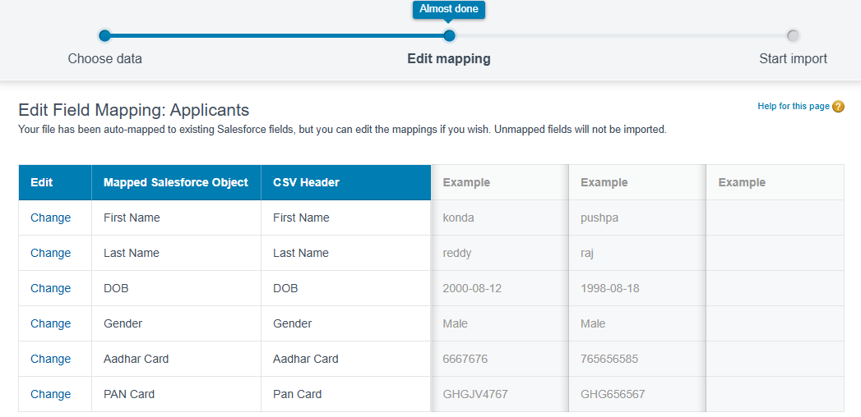
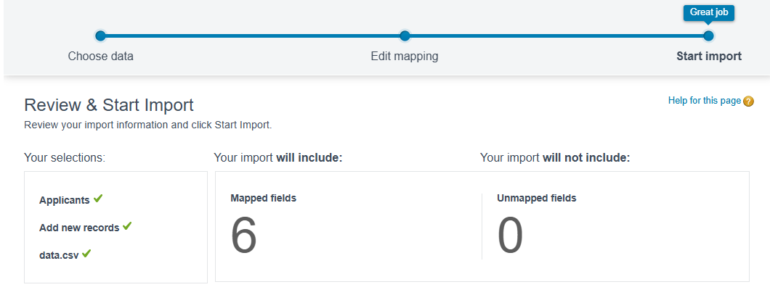
Step 10
Start the import.
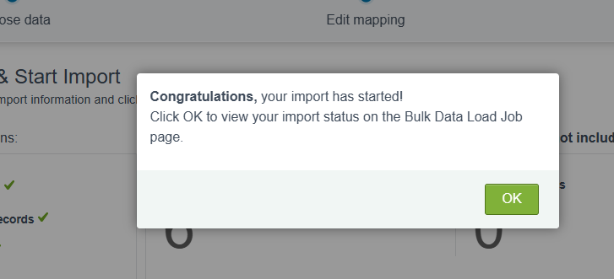
Result
The records from the CSV file will be imported into Salesforce.
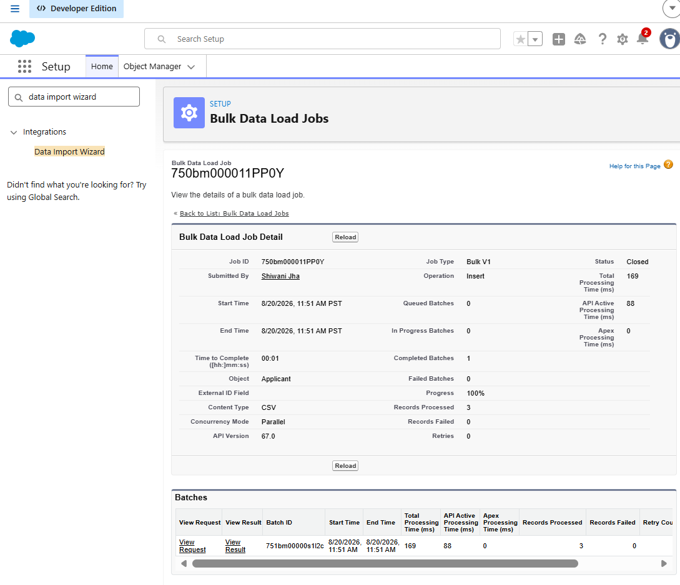
Click on “view result” to see the ids of the new applicants added.
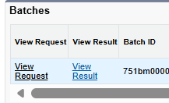
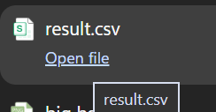
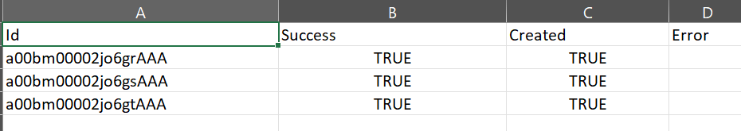

Add new data and update existing data-
Csv:
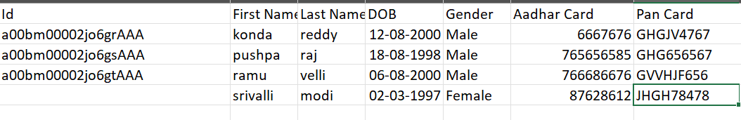
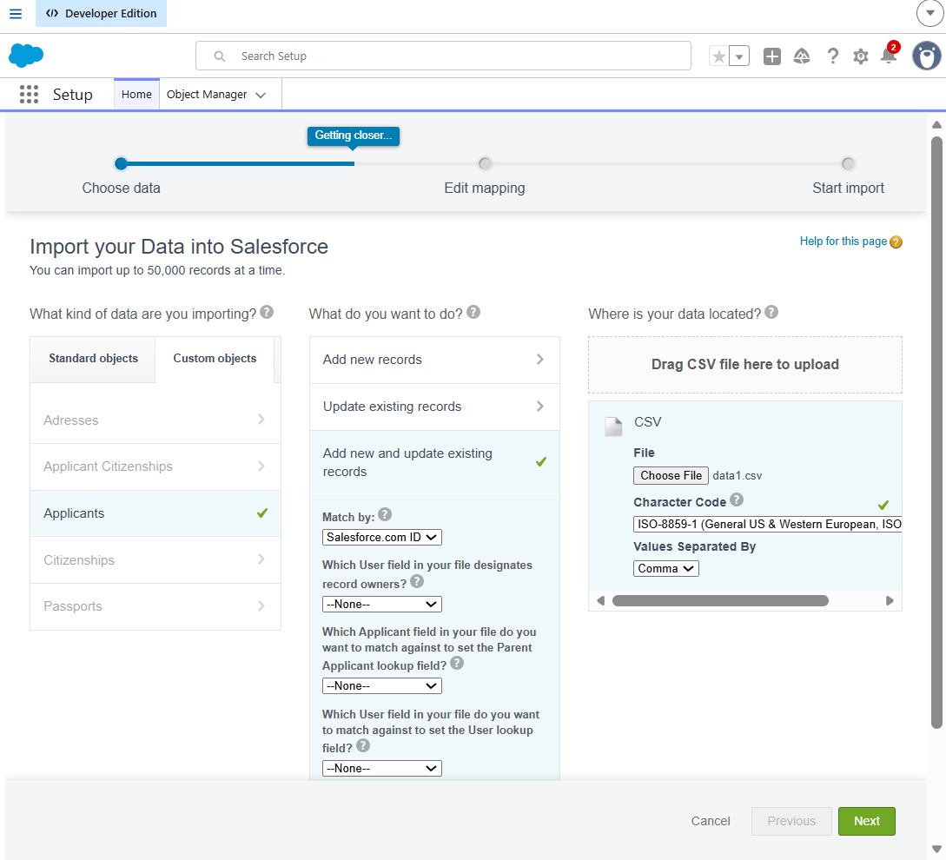
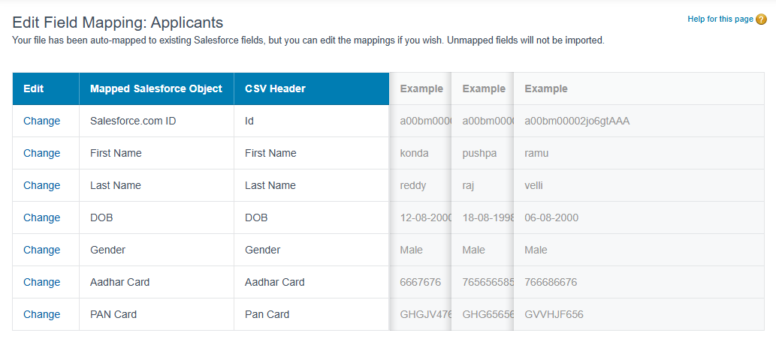
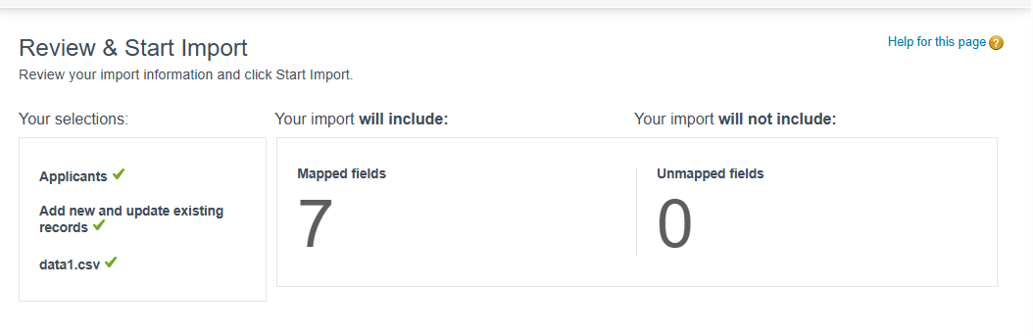
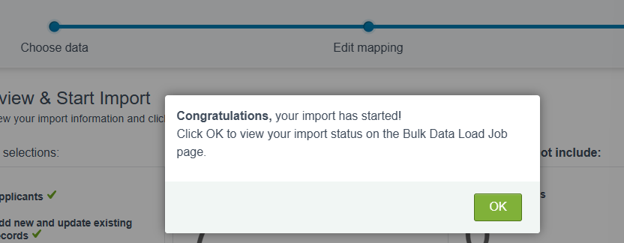
Similarly you will get result excel sheet with ids.

Data Export Wizard — Steps
Step 1
Go to Setup.
Step 2
In Quick Find, search for:
Data Export
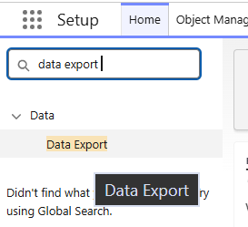
Step 3
Open Data Export.
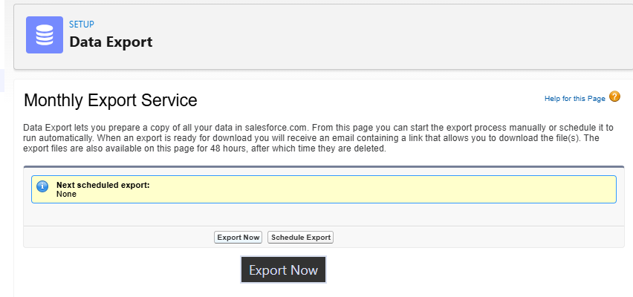
Step 4
Click Export Now.
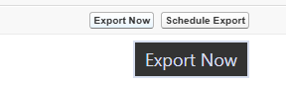
Step 5
Select the data/objects that you want to export.
Step 6
Select the required export options.
Step 7
Click Start Export.
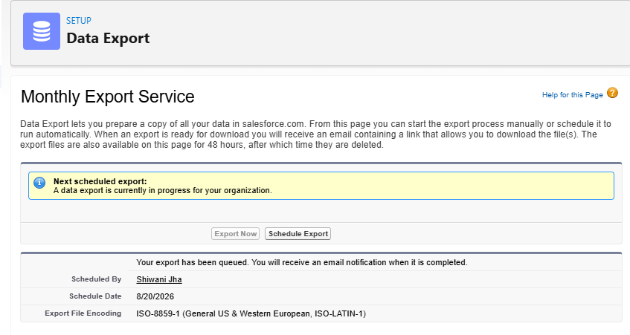
Result
Salesforce prepares the selected data for export, which can then be downloaded.
“Your export has been queued. You will receive an email notification when it is completed”

15-digit ID vs 18-digit ID
Salesforce records have a 15-character ID and an 18-character ID.
15-digit ID | 18-digit ID
Case-sensitive | Case-insensitive
Commonly seen in Salesforce UI | Commonly used in Excel, Data Loader, integrations, etc.
001XXXXXXXXXXXX | 001XXXXXXXXXXXXXXX
Why Excel shows 18 digits?
When you export Salesforce data or work with data through tools such as Data Loader, Salesforce commonly provides the 18-character ID.
The extra 3 characters at the end are a case-insensitive checksum/suffix. They help preserve the uniqueness of the ID when a system such as Excel doesn't reliably distinguish uppercase and lowercase characters.
Example
Suppose Salesforce UI shows:
001ABC123XYZ789
The 18-character version might look like:
001ABC123XYZ789ABC
The first 15 characters identify the same Salesforce record, while the final 3 characters are added for the 18-character, case-insensitive version.

Apid-00000013
a00bm00002e1vYrAAI
- Case insensitive
- 3 additional chars are added
- Designed to work safely with systems such as excel and other ext tools
a00bm00002e1vYr
- Case sensitive
- Older/salesforce id format
Excel or databases/configurations that use case-insensitive comparisons, may treat them as the same. The 18-character ID adds 3 extra characters that encode the capitalization of the original 15 characters.
apid-00000018
a00bm00002jo6grAAA
apid-000000005
a00bm00002d0pFxAAI
apid-0000000011(classical mode)
a00bm00002e0CtF

